Mrs. Danaher’s Class Supply List

Here is a list of supplies that better reflect the needs of our classroom. However, if you have already bought supplies from the general Wallace list, that is perfectly fine! Please bring in the remainder of the below items with your child throughout the first week of school. I understand that some items might be in limited supply (ex. wipes, hand sanitizer) and if you are unable to find any at this time, that is okay!

- Backpack
- 1 Personal Reusable Water Bottle
- 1 School Art Box
- Baby Wipes (1 pack)
- Hand Sanitizer
- Headphones (preferred over earbuds)
- Glue Sticks (2)
- 1 Folder (any color or pattern)
- Clorox Wipes (1)
- Sandwich Sized Baggies (1 box) GIRLS
- Gallon Sized Baggies (I box) BOYS
- Dry Erase Markers
- Scissors

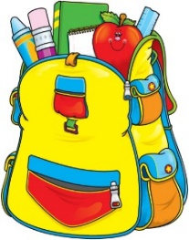
***I am aware that it is very common to ask for tissues, but at this time we have plenty! I will reach out when we need more.

Thank you!

